


















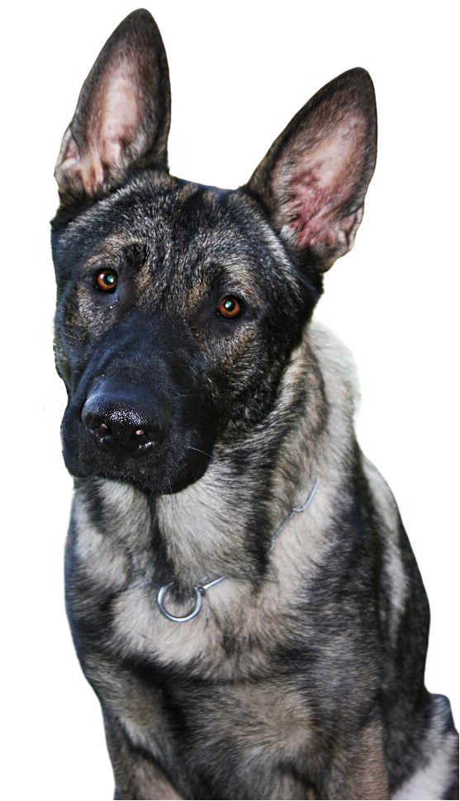
WITHOUT IDENTIFICATION,
A LOST DOG MAY NEVER
MAKE IT HOME.

Failure to have your dog licensed may result in a fine of up to $500 plus court costs.
All dogs must be licensed when you buy or adopt them (earliest is 8 weeks old) or 3 months of age, whichever comes first, by Jan. 1 of each year.
Your best friend’s best chance
to make it home safely is to be properly licensed.

How much does a license cost?

Annual Licenses . . . . . . . . . . . . . . . . . . . . . . . . . . . . . . . . $10.80
Lifetime Licenses . . . . . . . . . . . . . . . . .. . . . . . . . . . . . . $52.80

Senior Citizens or Residents with Disabilities:
Annual Licenses . . . . . . . . . . . . . . . . . . . . . . . . . . . . . . . . $8.80
Lifetime Licenses . . . . . . . . . . . . . . . . . . . . . . . . . . . . . $36.80

Licenses can be obtained through
your County Treasurer.
For a list of County Treasurers, visit
www.licenseyourdogpa.com

How to apply for
a Dog License

Bucks County Treasurer
55 E Court Street, 5th Floor
Doylestown, PA 18901
215-348-6244
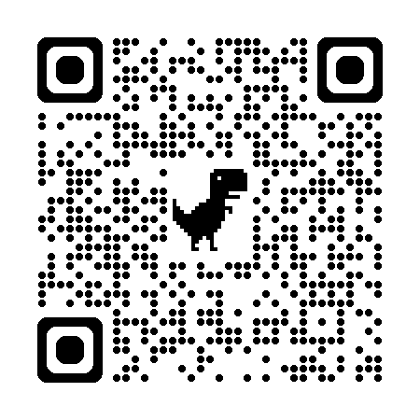
Scan to apply online or find a location to purchase in person!


For more information, contact the
PA Department of Agriculture at:
717.787.3062

