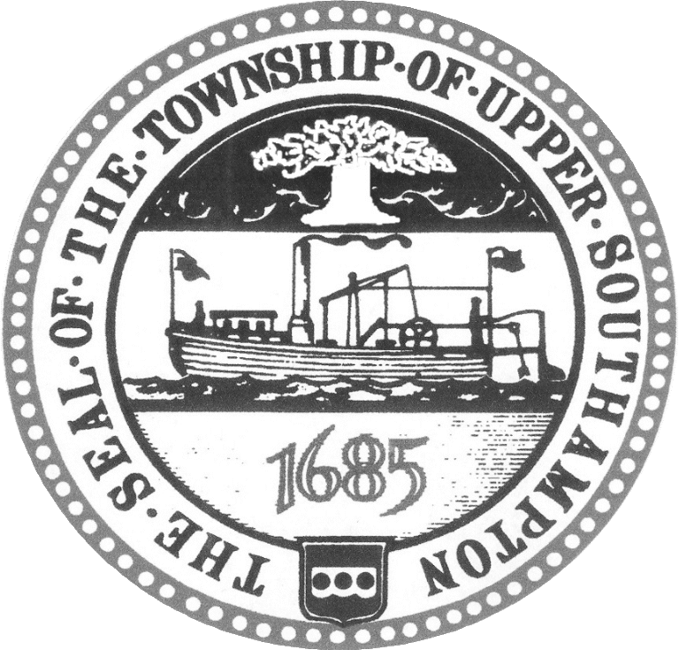 **UPPER SOUTHAMPTON TOWNSHIP**

939 STREET ROAD • SOUTHAMPTON, PENNSYLVANIA 18966-4787

COUNTY OF BUCKS

PHONE: 215.322.9700 • FAX (215) 322-0405

Upper Southampton Township

Dedication of Administrative Building Flagpole

6 P.M. – July 8, 2025

Opening Remarks

Unveiling of the Plaque

Comments from Board of Supervisors

Comments from Cody Spadaccino

Presentation of Colors by VFW Post 64933 - Warminster Color Guard

Adjournment

